Day 5 — Transformations and Actions

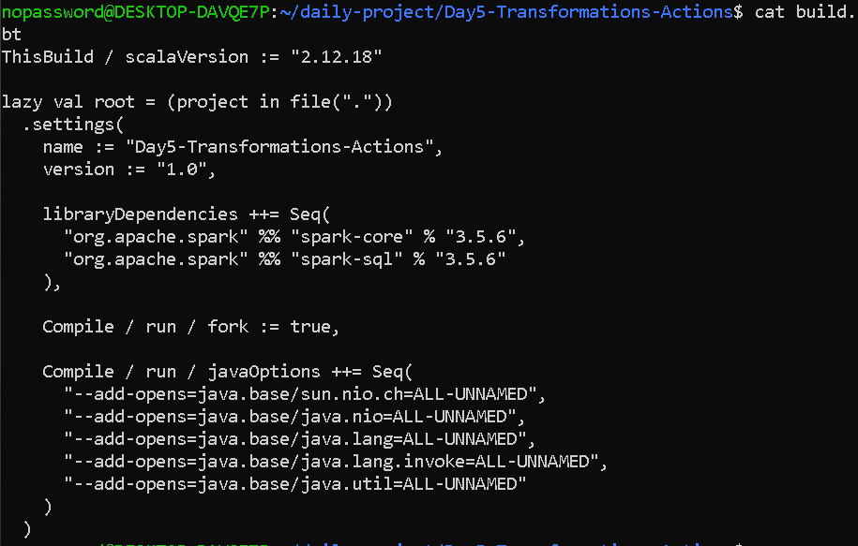

nopassword@DESKTOP-DAVQE7P:~/daily-project/Day5-Transformations-Actions$ cat src/main/scala/TransformationsActions.scala
import org.apache.spark.sql.SparkSession

object TransformationsActions {

def main(args: Array[String]): Unit = {

val spark = SparkSession.builder()
.appName("Day5 Transformations and Actions")
.master("local[*]")
.getOrCreate()

val sc = spark.sparkContext
sc.setLogLevel("ERROR")

println("======================================")
println("DAY 5 - TRANSFORMATIONS AND ACTIONS")
println("======================================")

// ----------------------------------
// 1. Create RDD
// ----------------------------------

val numbers = sc.parallelize(List(1, 2, 3, 4, 5))

println("\nOriginal RDD:")
println(numbers.collect().mkString(", "))

// ----------------------------------
// 2. MAP
// ----------------------------------

val doubled = numbers.map(x => x * 2)

println("\nMAP - Doubled values:")
println(doubled.collect().mkString(", "))

// ----------------------------------
// 3. FILTER
// ----------------------------------

val evenNumbers = numbers.filter(x => x % 2 == 0)

println("\nFILTER - Even numbers:")
println(evenNumbers.collect().mkString(", "))

// ----------------------------------
// 4. FLATMAP
// ----------------------------------

val sentences = sc.parallelize(
List(
"Spark is fast",
"Spark is powerful",
"Big data with Spark"
)
)

val words = sentences.flatMap(line => line.split(" "))

println("\nFLATMAP - Words:")
println(words.collect().mkString(", "))

// ----------------------------------
// 5. DISTINCT
// ----------------------------------

val duplicateNumbers =
sc.parallelize(List(1, 2, 2, 3, 3, 3, 4, 4, 5))

val uniqueNumbers = duplicateNumbers.distinct()

println("\nDISTINCT - Unique numbers:")
println(uniqueNumbers.collect().sorted.mkString(", "))

// ----------------------------------
// 6. UNION
// ----------------------------------

val rdd1 = sc.parallelize(List(1, 2, 3))
val rdd2 = sc.parallelize(List(4, 5, 6))

val combined = rdd1.union(rdd2)

println("\nUNION - Combined RDD:")
println(combined.collect().mkString(", "))

// ----------------------------------
// 7. COUNT
// ----------------------------------

val count = numbers.count()

println("\nCOUNT:")
println(s"Number of elements = $count")

// ----------------------------------
// 8. COLLECT
// ----------------------------------

println("\nCOLLECT:")
println(numbers.collect().mkString(", "))

// ----------------------------------
// 9. FIRST
// ----------------------------------

println("\nFIRST:")
println(numbers.first())

// ----------------------------------
// 10. TAKE
// ----------------------------------

println("\nTAKE:")
println(numbers.take(3).mkString(", "))

// ----------------------------------
// 11. REDUCE
// ----------------------------------

val sum = numbers.reduce((a, b) => a + b)

println("\nREDUCE:")
println(s"Sum = $sum")

// ----------------------------------
// 12. LOG ANALYZER
// ----------------------------------

println("\n======================================")
println("LOG ANALYZER")
println("======================================")

val logRDD = sc.textFile("data/app.log")

println("\nTotal log lines:")
println(logRDD.count())

// Filter ERROR messages
val errorLogs = logRDD.filter(line => line.contains("ERROR"))

println("\nERROR messages:")
errorLogs.collect().foreach(println)

// Count ERROR messages
val errorCount = errorLogs.count()

println(s"\nTotal ERROR messages = $errorCount")

// Extract ERROR text using map
val errorMessages = errorLogs.map(line => line.split("ERROR")(1).trim)

println("\nExtracted ERROR messages:")
errorMessages.collect().foreach(println)

// ----------------------------------
// LOG ANALYZER USING FLATMAP
// ----------------------------------

val errorWords = errorLogs.flatMap(line => line.split(" "))

println("\nWords from ERROR logs:")
println(errorWords.collect().mkString(", "))

// ----------------------------------
// DISTINCT ERROR MESSAGES
// ----------------------------------

val uniqueErrors = errorMessages.distinct()

println("\nUnique ERROR messages:")
uniqueErrors.collect().foreach(println)

// ----------------------------------
// FIRST ERROR
// ----------------------------------

println("\nFirst ERROR:")
println(errorLogs.first())

// ----------------------------------
// FIRST 2 ERRORS
// ----------------------------------

println("\nFirst 2 ERROR messages:")
errorLogs.take(2).foreach(println)

spark.stop()
}
}

OUTPUT—
